**41081 Lab 3 Results**

|  |  |  |  |
| --- | --- | --- | --- |
| **Student Number** | 13555089 | **Student Name** | Ryan Cleminson |
| **Subject ID** | 41081 | **Subject Name** | Sensing Actuation and Control |

**Task 1:** **Motion-triggered lamp (4 points)**

* 1. Implement the above system using RIBS (2 points)

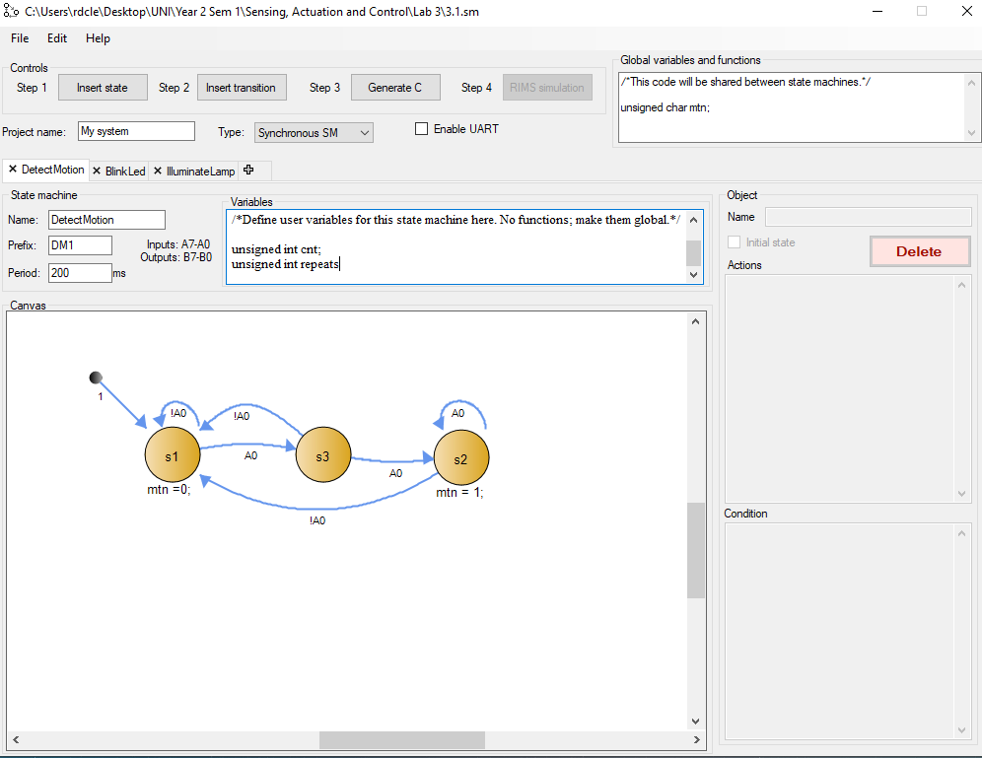

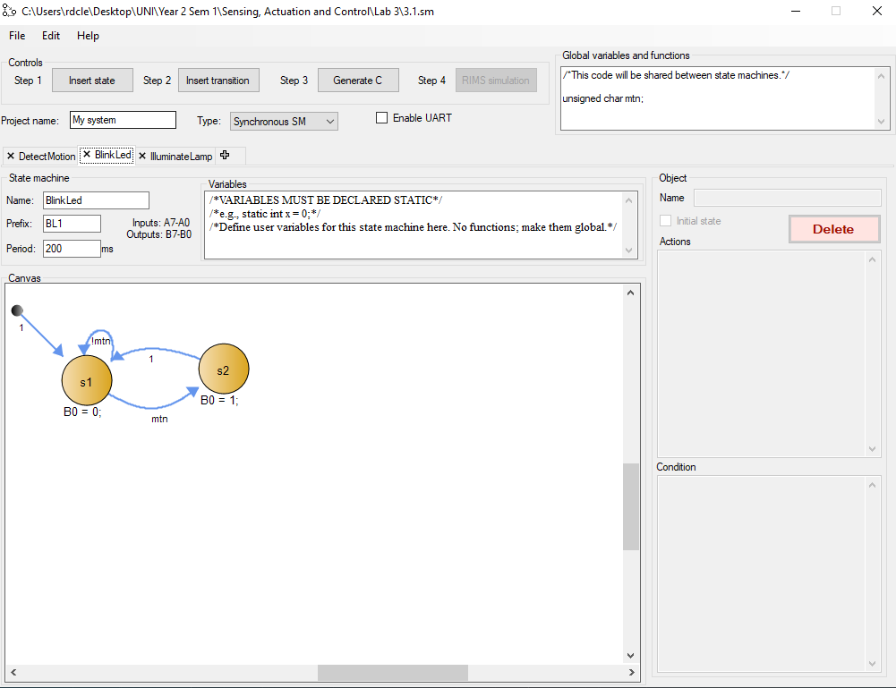

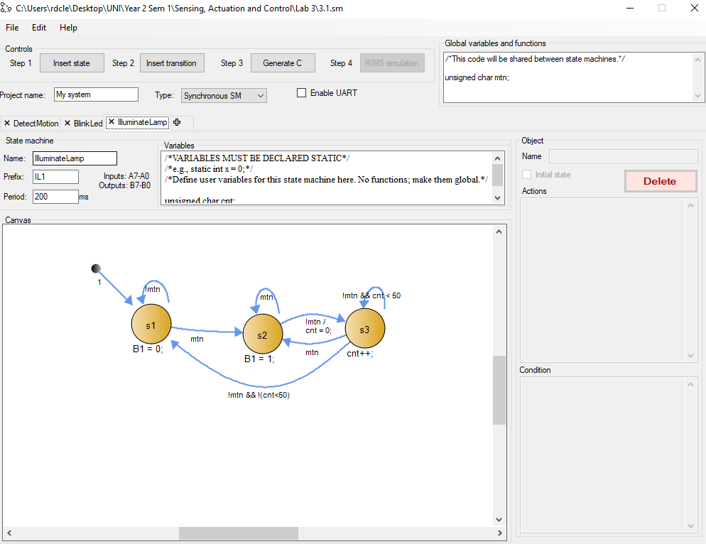

* 1. Extend the above system by: having 3 buttons to connect to A1 A2 A3 to control the duration of keeping the lamp on past the last detected motion(while button is pressed). 5seconds, 10 seconds and 15 seconds for A1 A2 and A3 accordingly (The default duration is 3 seconds, ie., no button is pressed) (2 points)

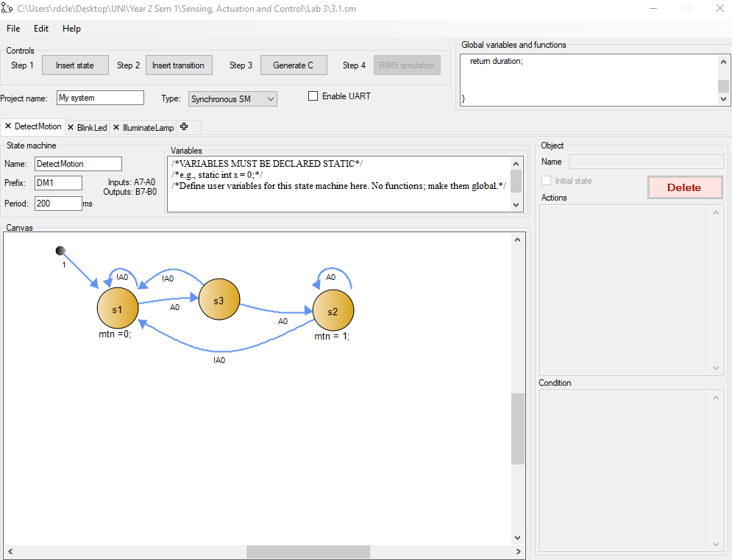

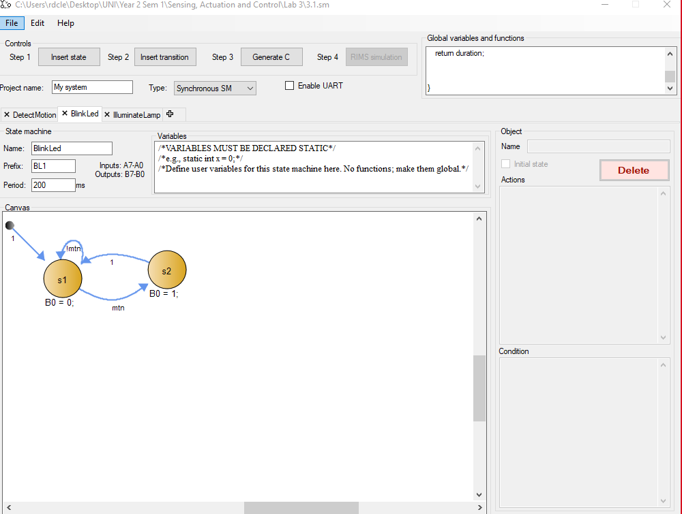

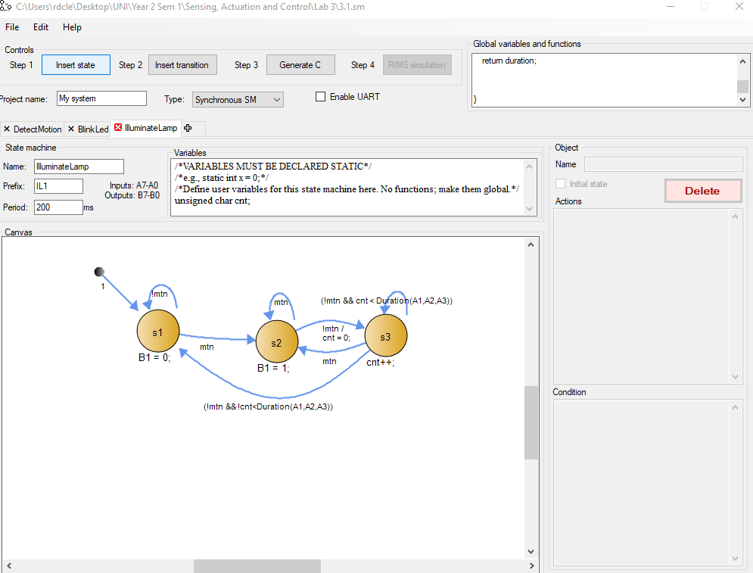

**Task 2: Door-lock system (6 points).**

2.1 Implement the above system using RIBS (2 points).

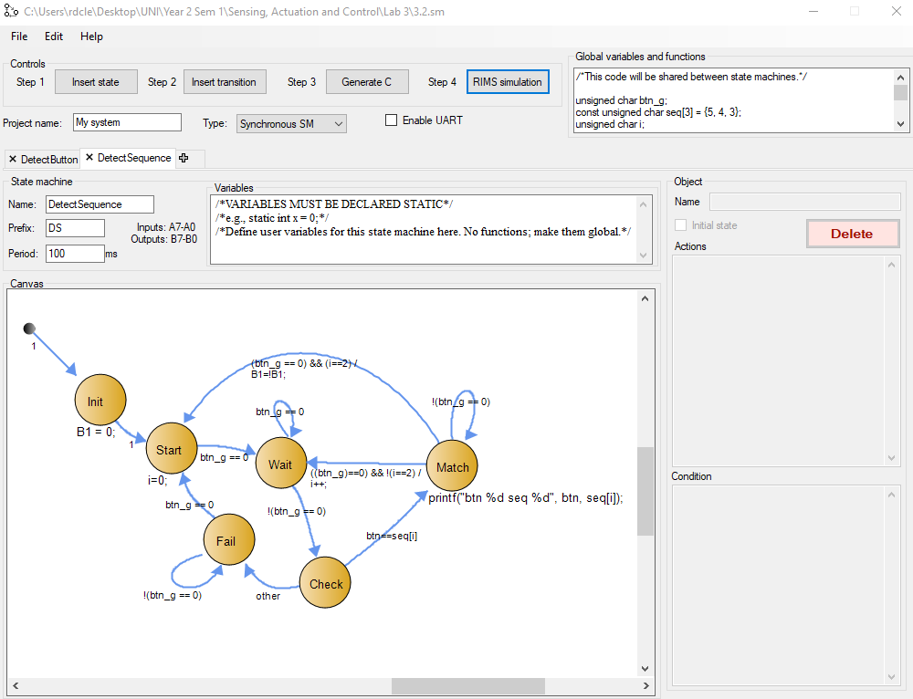

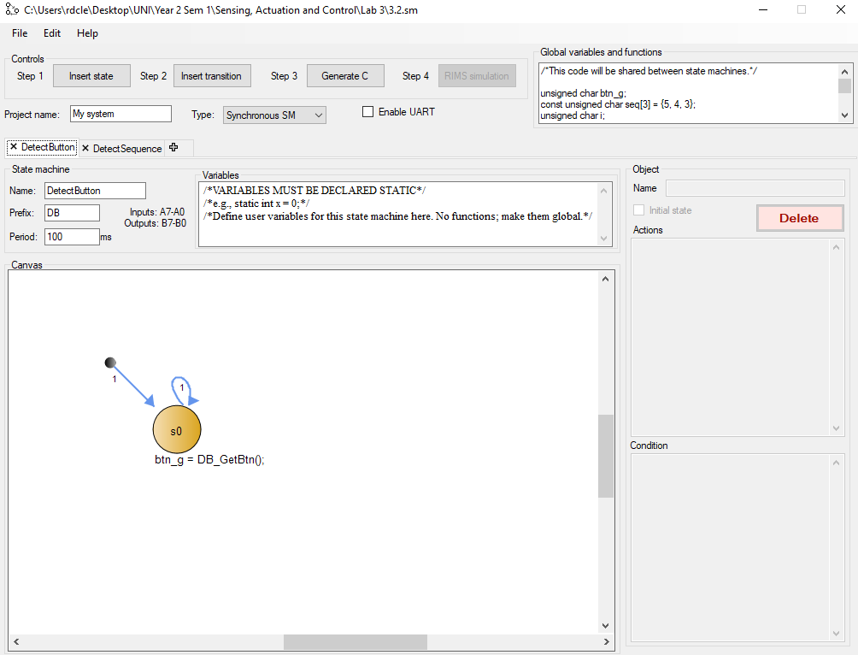

2.2 Extend the above system so that the digital key is (3 2 1 5 4). (2 points)

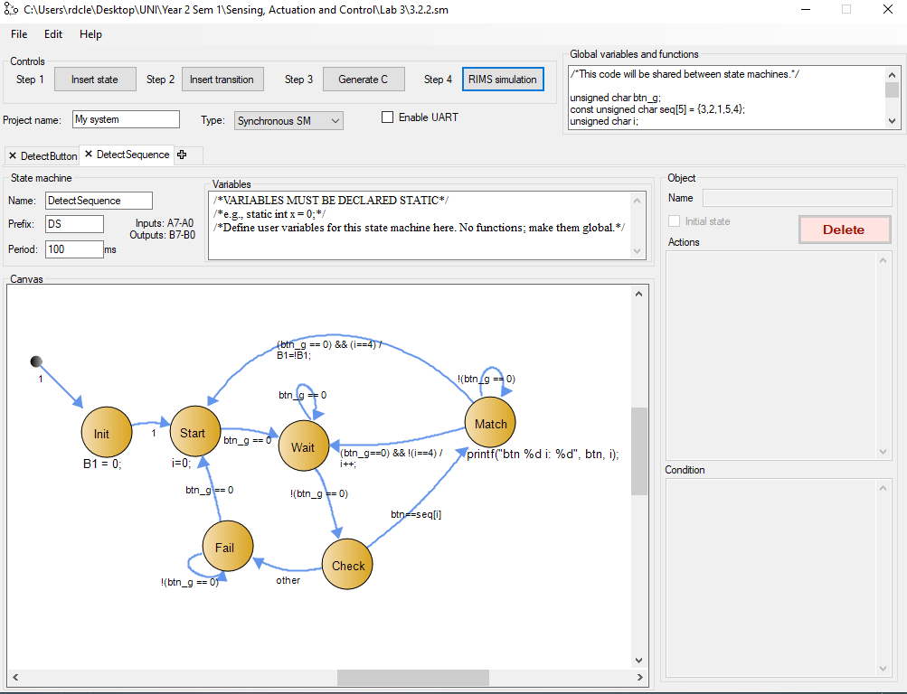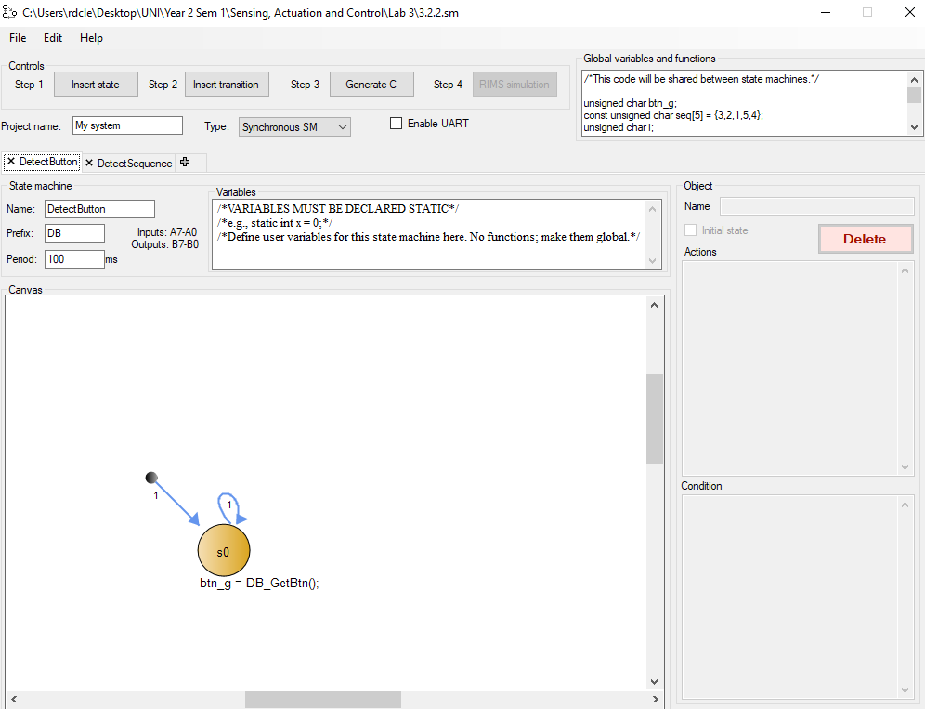

2.3 Extend the above system so that the LED (connected to B2) will be on for 5 seconds when the lock is open/toggled (2 points)

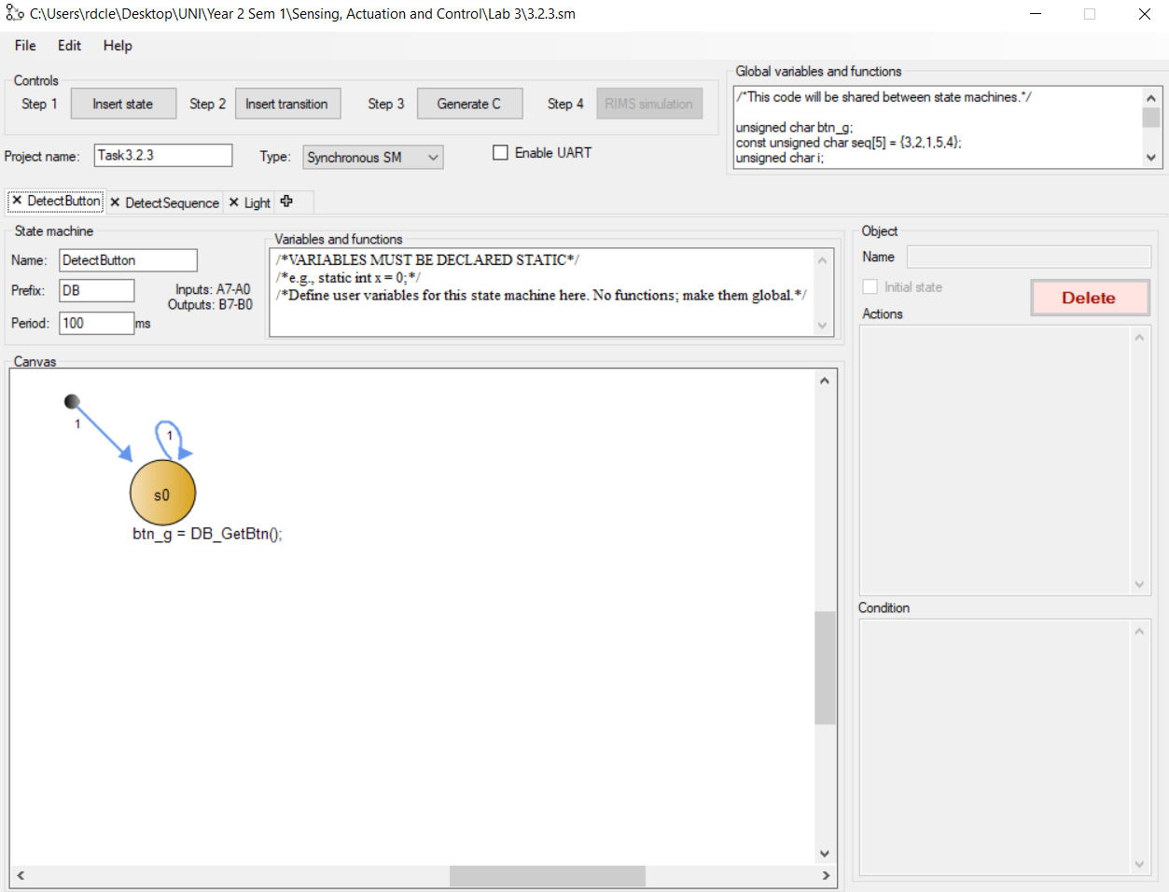

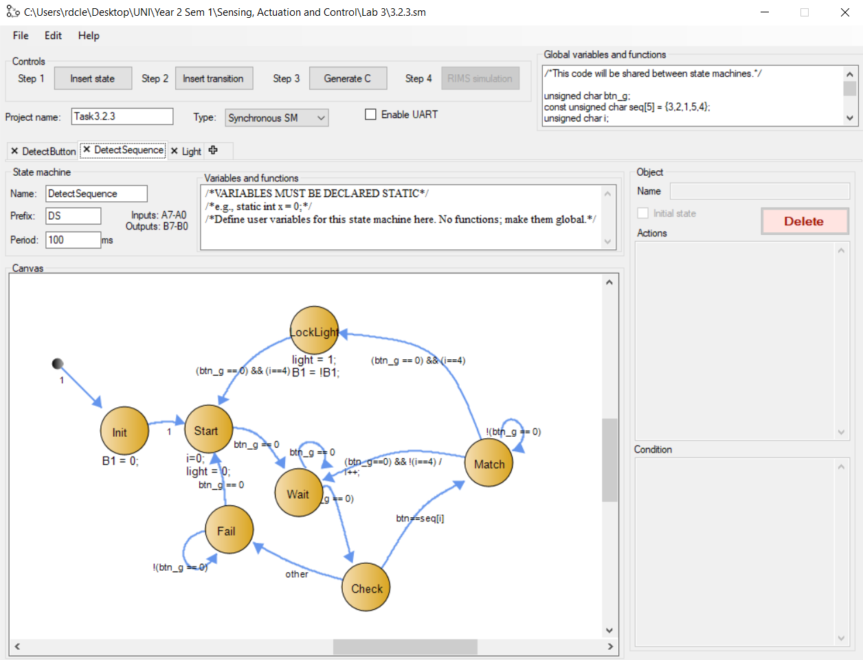

S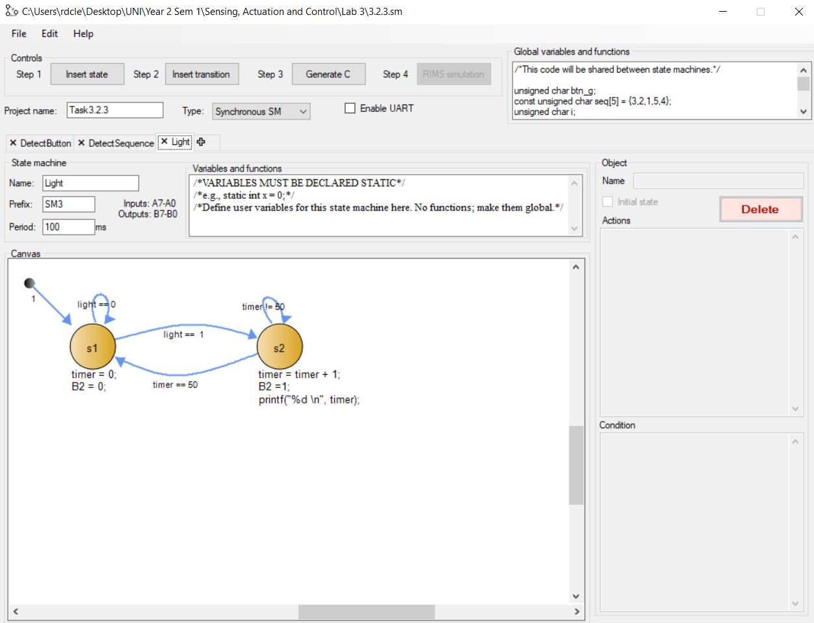

**Task 3: Simplified digital piano (5 points)**

3.1. Design and Implement the above digital piano system in RIBS (4 points)

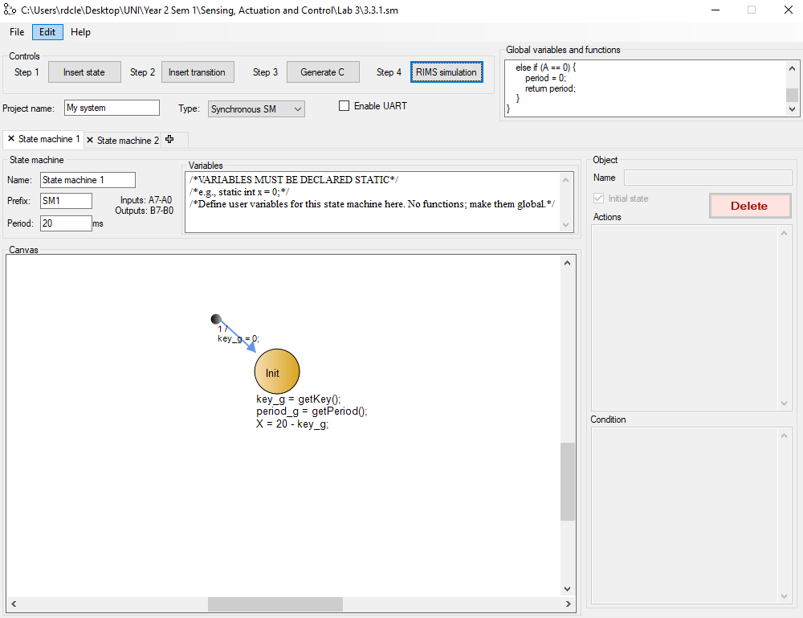 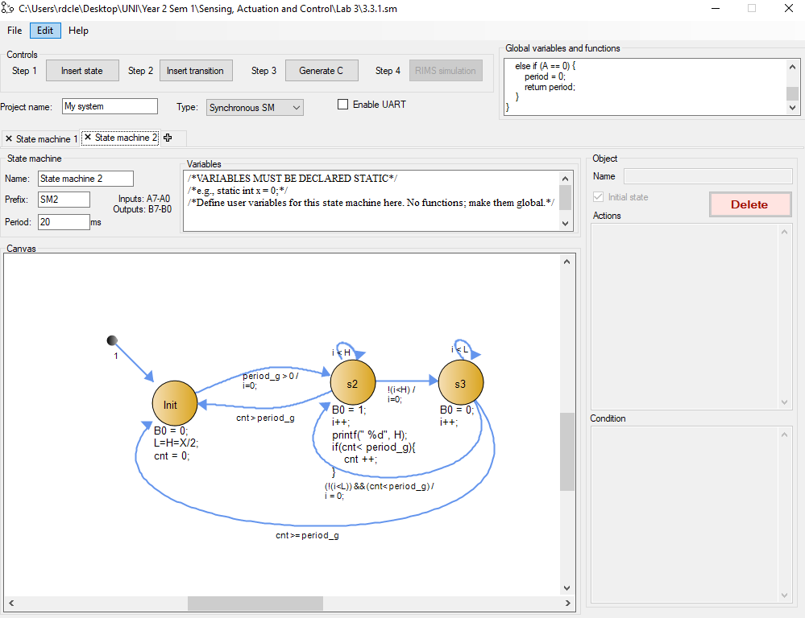

3.2 Display screenshot of RIMS when A = 32, print H value.(1 point)

